Team Contribution Doc

**Week 1**

**Charles:**

* Upload most of the world settings of Cyberpunk into the discord channel.

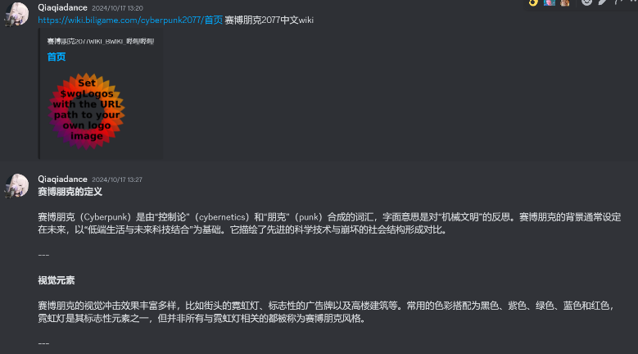

* Created the plot tree diagram
* Finished most of the main story line
* Patch Update Note 1.0
  + Story structure is changed, for now, The male and female protagonists will experience the same story, with only slight differences in the details of their actions or in their dialogue.